Empowering District-level Decision Makers to Strengthen their Local Health Systems

In Guinea, the Ebola outbreak further damaged an already frail health system suffering from a combination of weak governance, transparency, and accountability at all levels. It highlighted shortcomings at the district level, where district health teams are increasingly responsible for management of services and resources. To successfully implement these additional responsibilities district teams require increased capacity to respond holistically and proactively to local health systems challenges.

In 2016, the USAID-funded Maternal and Child Survival Program (MCSP) provided technical assistance in health systems strengthening to the Government of Guinea (GoG), focusing on the district level, to help ensure access to quality reproductive, maternal, newborn, and child health services. First, MCSP supported Guinea’s Ministry of Health (MoH) to implement a Rapid Health System Assessment (RHSA) in four MCSP-supported regions that experienced the highest Ebola burden: Conakry, Kindia, Boké, and N’Zérékoré. The aim of this assessment was to rapidly diagnose health system barriers as well as best practices at the sub-national level to provide local decision makers with evidence they can use to strengthen their health systems. Next, MCSP, in collaboration with the MoH, rolled out the MCSP-developed process, the Comprehensive Approach to Health Systems Management in the four districts. The Comprehensive Approach was piloted by MCSP in Tanzania in July 2015 and aims to support district teams in developing and implementing integrated work plans that address local health systems challenges by taking advantage of local assets and thinking holistically. The Approach builds off the results of the RHSA, using RHSA findings as evidence for action.

MCSP and MoH facilitated four three-day regional workshops focused on building district teams’ capacity to implement the Comprehensive Approach. Workshop facilitators guided participants through a series of interactive activities aimed at: (1) developing a shared understanding of the health systems building blocks; (2) increasing their understanding of the roles and responsibilities of district health managers; (3) identifying district health system priority problems; (4) developing a list of local resources; and (5) determining corrective actions and plans for solving the problems using the local resources. This Approach encourages district teams to take ownership of their problems by first understanding the problem’s root cause and then identifying local resources they can use or advocate for to mitigate the problem. The Approach also encourages district teams to recognize the importance of all actors in the local health system, and to value them as assets that can be leveraged for supporting improvements. As such, participants at these workshops included more than just the district health teams. Participants also included community representatives, representatives from health facilities, community health workers, local government, and local development partners all working together through workshop activities.
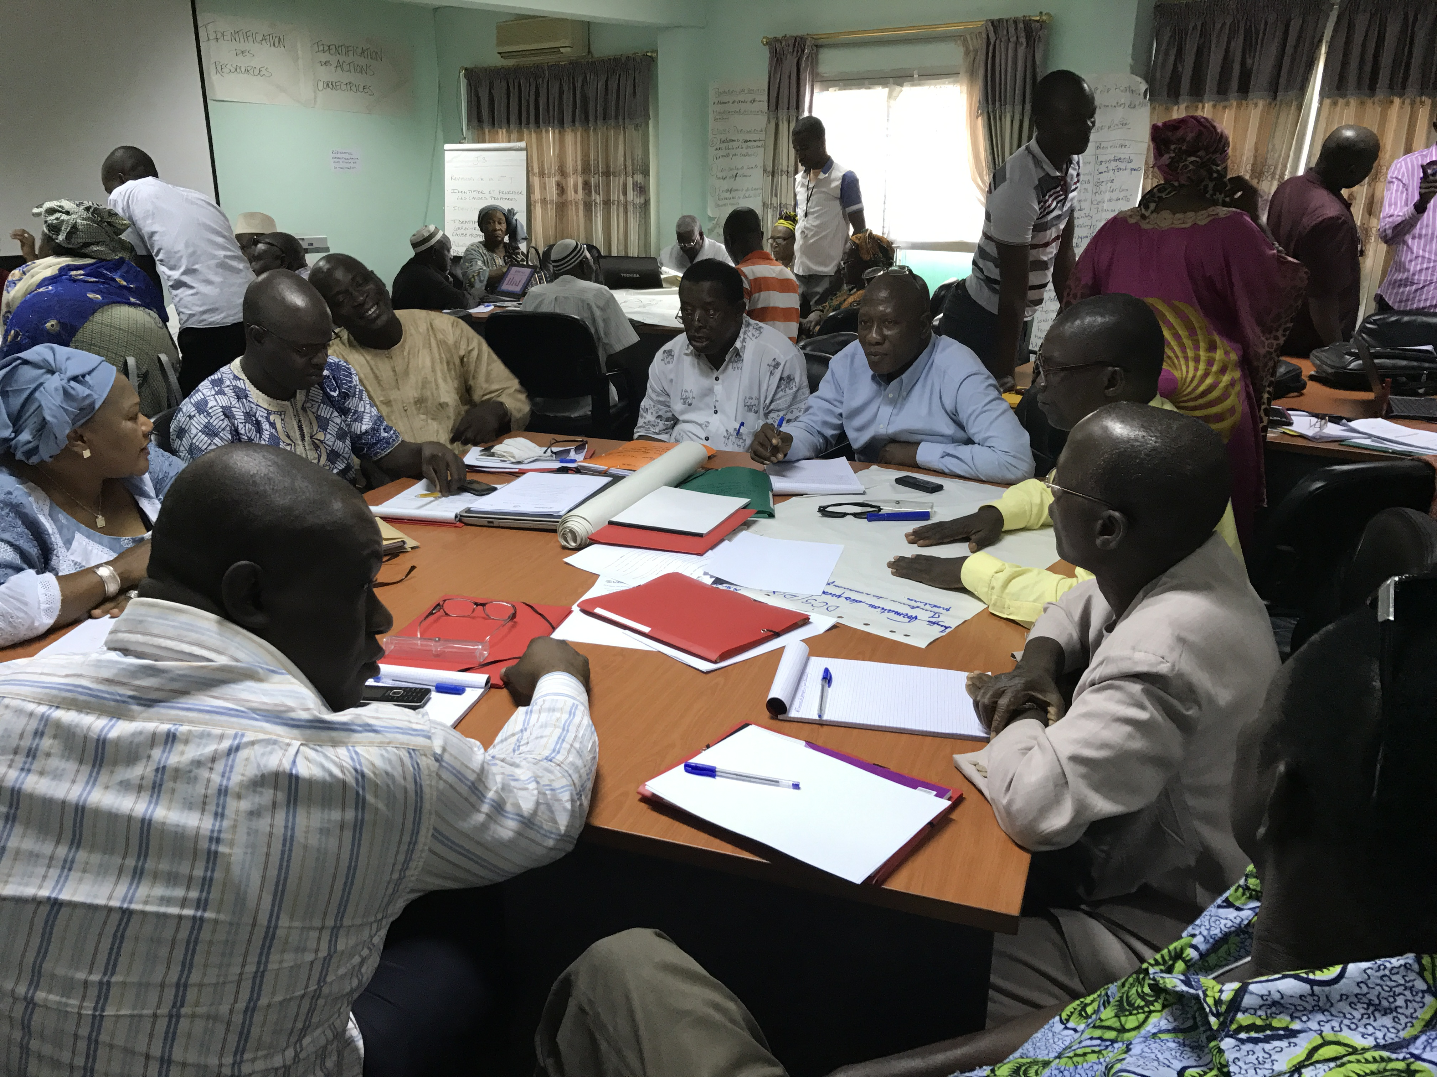
Photo: MCSP/Meera Suresh
District health teams discuss management roles and responsibilities at the Comprehensive Approach workshop.

Participants viewed the workshops as very successful and recognized the importance of learning an approach that allows them to address challenges themselves, using local solutions instead of relying on the national level. MCSP recognizes the importance of continued support to Guinea’s district teams to sustain and institutionalize this approach in Guinea. Since the workshops, MCSP has provided district health managers with syntheses of the work they completed during the workshop, and worked with them to incorporate these results into their local planning activities for 2017. MCSP also developed a tool that captures the key elements of the Comprehensive Approach, and shared this with district teams so they can continue to implement the Approach in their districts.
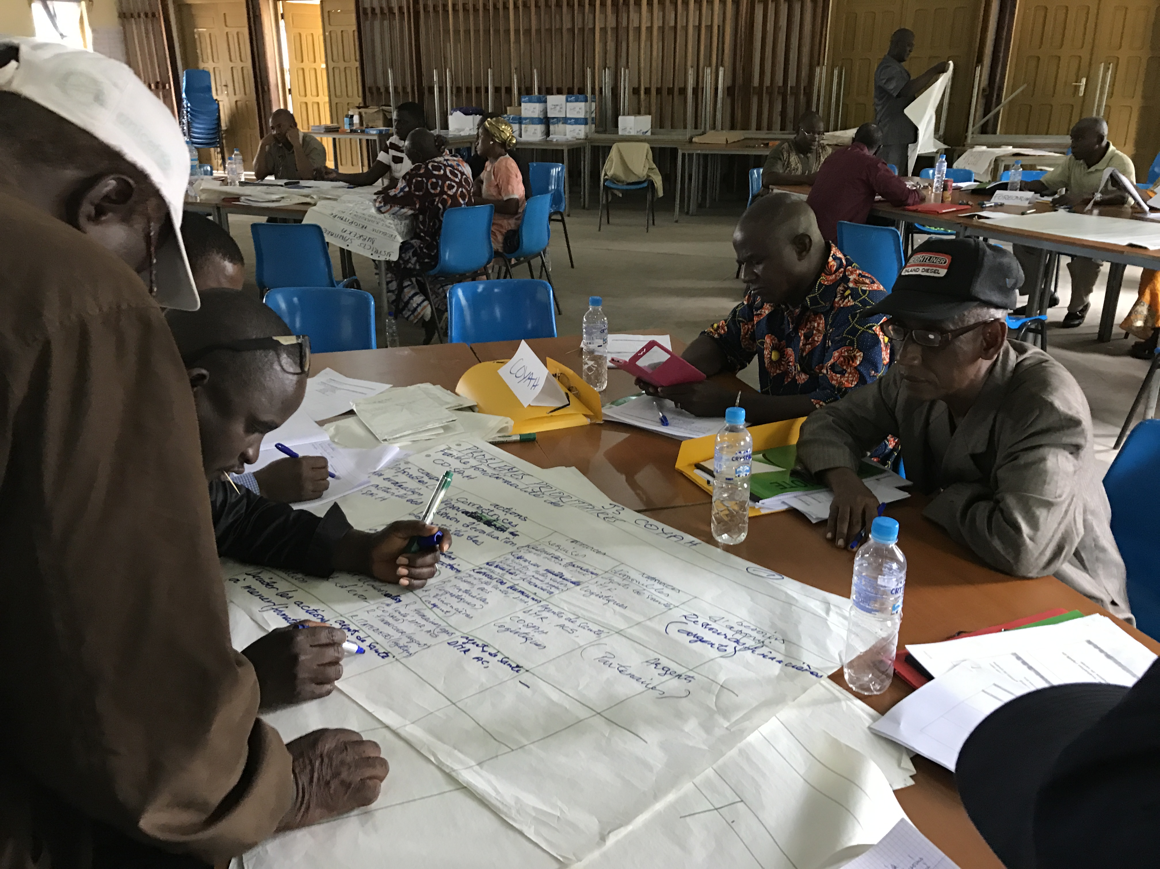
Photo: MCSP/Meera Suresh
Health managers identify local resources within their district health teams at the Comprehensive Approach workshop.

The RHSA and Comprehensive Approach implementation in Guinea had an important secondary benefit, that of building national level ministry capacity. The MCSP team worked intentionally to collaborate with the MoH to implement the work in Guinea. Through this collaboration the MoH increased capacity to implement and train others in this Approach. They have also become champions for the Approach and have expressed interest scaling it up across Guinea’s four additional regions. Further, they have expressed interest in institutionalizing the Approach by integrating it into their annual work planning process. In addition, several external partners have expressed interest and readiness to support activities identified during the workshops.
“We will leave here with this great innovation [the Comprehensive Approach] and will have thought through many solutions.”
-District health team participant

“We will use these recommendations [developed during this workshop] to advocate to the local government [for support implementing our activities].”
-District health team participant

District health teams are on their way to implementing sustainable solutions to health system challenges tailored to their local context. MCSP will continue to support them in their endeavor. In 2017 MCSP will continue to provide technical assistance to district health teams to build their capacity in district health system management by conducting mentoring visits to district teams and regional trainings in leadership, stakeholder coordination, and resource management. MCSP will also support Guinea’s MoH to institutionalize and scale-up the Comprehensive Approach nationally.

