March 2017 www.mcsprogram.org

Strengthening the Health System to Improve RMNCH Outcomes

Legacy
By undertaking system-strengthening activities that directly support the delivery of high-impact RMNCH interventions, MCSP will develop managers at national, subnational, and facility levels more capable of mobilizing available resources and addressing existing and future system bottlenecks to achieve sustained quality and coverage of high-impact RMNCH interventions. In at least four countries, new MCSP-introduced approaches for financial analysis or integrated district management (across interventions and technical areas) will be incorporated into long-term planning and management processes.

Definition
“USAID invests in health systems strengthening (HSS) to promote country ownership and sustainability, scale-up solutions, and promote greater efficiencies in investments” and considers HSS as comprising “the strategies, responses, and activities that are designed to sustainably improve country health system performance.” Similarly, the WHO defines HSS as

improving [the] six health system building blocks and managing their interactions in ways that achieve more equitable and sustained improvements across health services and health outcomes

Strengthening the health system does not just mean working in one of the six health system building blocks; nor does it just mean providing various health system inputs. HSS means (1) going beyond building block inputs to improving the performance of each of the functions by changing policies, organizational structures, and behaviors that drive system performance to improve equity, coverage, quality, and efficiency, and (2) recognizing the interconnectedness between the functions and improving multiple functions in a complementary way to achieve performance improvements.

The cube below provides illustrative examples of system performance drivers. Using the workforce as an example, providing trained staff is a critical input but by itself might not ensure better performance. Trained staff complemented by a system of performance management strategies, appropriate reporting and oversight structures, clear authority, and positive incentives are much more likely to sustain improved performance. Many health programs focus on providing inputs to strengthen health system functions, which can deliver quick improvements but are only a temporary solution to a weak health system. Only by addressing the system performance drivers can MCSP achieve USAID’s goal of sustained health system performance improvements.

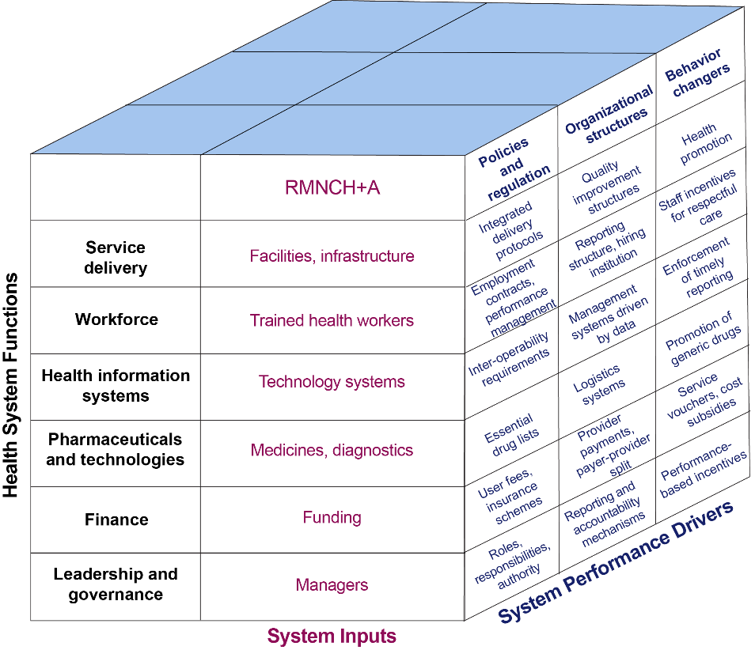

MCSP’s approach to HSS includes both incorporating a health system lens into the design and implementation of service delivery-focused activities, and supporting more ambitious interventions that address new components of the health system and/or cut across interventions to increase potential impact and sustainability.

Why is HSS important?
Sustained improvement of RMNCH outcomes cannot be achieved through a standalone program or individual interventions. It requires high-quality delivery of a complex set of clinical interventions at all levels of the health system from the community to the hospital level, effective referral systems that minimize delay in care and missed opportunities, strong information systems that identify potential problems and enable informed management decisions, and sustained leadership that coordinates available resources to resolve problems. High-impact interventions can only be sustained at scale if they are integrated into existing health system structures and processes, with simultaneous efforts to address the weaknesses within those same structures and processes that constrain performance.

MCSP’s approach to HSS focuses on addressing barriers that directly affect service delivery and supporting institutionalization and scale-up of high-impact interventions. Three high-value strategies that MCSP prioritizes are:

- Health financing, focusing on three areas (1) subnational budget and expenditure management, (2) financial incentives, including performance-based financing, (3) costing and cost-effectiveness analysis to inform programming and advocacy.
- Human resources, including innovative approaches to human capacity development in pre-service and in-service training, and health worker motivation and performance management.
- Leadership and management, focusing on policies and regulations that impact RMNCH, strengthening transparency and accountability, engaging civil society, and building leadership and management capacity.

What do we hope to achieve?
By developing additional tools and approaches that can be applied to RMNCH programs globally through the life of MCSP and beyond, MCSP helps countries provide high-quality sustainable RMNCH services at scale. More specifically, MCSP:
- Assists district health managers to improve planning and use of resources, prioritize system bottlenecks that constrain high-quality services and develop local solutions to alleviate those bottlenecks, and support improved performance and quality at service delivery sites.
- Ensures that decision-makers understand the cost of high-impact RMNCH interventions so they can allocate sufficient resources to sustain high coverage and quality at scale.
- Strengthens health worker motivation, support, and accountability systems to complement innovative approaches for human capacity development so that health workers are not only well trained but also feel empowered and accountable to provide quality services.

What progress have we made so far?
Two tools have been developed and implemented to help countries design HSS activities that complement existing programs:
- The Rapid Health System Assessment (RHSA) diagnoses system constraints and bottlenecks and prioritizes areas for improvement. The RHSA has been used in four countries to document system constraints and identify options for MCSP programming to address those constraints.
- The Comprehensive Approach to Health System Management helps district health managers prioritize health system constraints and identify resources that can be used to improve health services. The Comprehensive Approach has been applied in two countries to help district managers develop their own plans for addressing priority system constraints.
MCSP has also incorporated activities to strengthen health systems by building the capacity of district and regional managers, improving data and analysis for management and planning, and analyzing costs for scale-up to inform planning and advocacy. MCSP has also identified learning questions related to alternative approaches for capacity development to improve knowledge and skills. The table below summarizes activities across MCSP countries.

Current Implementation of Hss Activities
Approach | Countries
- Strengthen subnational management capacity | Bangladesh, Haiti, Kenya, Mozambique, Nigeria, Rwanda, Tanzania
- Improve visualization, analysis and use of health information system data by health system managers | DRC, Kenya, Madagascar, Mozambique, Namibia, Nigeria, Rwanda, Tanzania, Uganda
- Cost analysis to inform scale-up and implementation of high-impact interventions | Ghana, Rwanda, Uganda
- Rapid Health System Assessment | Guinea, Mozambique, Nigeria, Rwanda
- Comprehensive Approach to Health System Management | Guinea, Tanzania
- Apply and learn from innovative approaches to human capacity development | Egypt, Ethiopia, Ghana, Liberia, Madagascar, Mozambique, Nigeria, Rwanda

What more could be done?
There are additional opportunities for MCSP countries to incorporate HSS activities to increase coverage and quality of RMNCH services. Two priority areas of opportunity are:

- Financing: Where MCSP is supporting scale-up of high impact interventions, analysis to understand the cost of maintaining the intervention post-MCSP is critical to ensuring sustainability. Analysis of the cost of nationwide scale-up is also critical, so that high-impact interventions can be implemented at national scale.
- Human resources: Where MCSP is developing the capacity of health workers, incorporate additional activities to support health worker motivation, such as:
  - Examine and address workplace conditions that undermine quality services and demotivate staff.
  - Develop financial and nonfinancial performance-based incentives, funded through in-country resources.
  - Engage with facility and district managers to clarify authority structures that allow staff to take actions to address problems.
  - Engage with facility and district-level managers and with community structures to develop appropriate accountability mechanisms.

MCSP will also document learning on innovative approaches to human capacity development, including low-dose high-frequency facility-based training, mentoring, and structured supportive supervision across country programs, providing guidance to improve the efficiency and effectiveness of these approaches.

USAID’s Vision for Health Systems Strengthening 2015–2019, September 2015.
WHO, Everybody’s Business.

